**Database model**

A Database model defines the logical design and structure of a database and defines how data will be stored, accessed and updated in a database management system.  The database model defines the manner in which the various files of a database are linked together. While the **Relational Model** is the most widely used database model, there are other models too:

1. Hierarchical Database Model (HDBM)
2. Network Database Model (NDBM)
3. Object-Oriented Database Model (OODBM)
4. Entity Relational Data Model (ERDM)
5. Relational Database Model (RDBM)
6. **Hierarchical Model**

This database model organizes data into a tree-like-structure, with a single root, to which all the other data is linked. The hierarchy starts from the **Root** data, and expands like a tree, adding child nodes to the parent nodes.

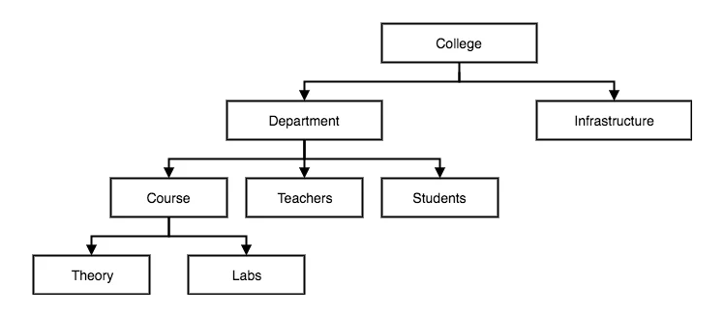

1. **Network Model**

This is an extension of the Hierarchical model. In this model data is organized more like a graph, and are allowed to have more than one parent node.

In this database model data is more related as more relationships are established in this database model. Also, as the data is more related, hence accessing the data is also easier and fast. This database model was used to map many-to-many data relationships.

This was the most widely used database model, before Relational Model was introduced.

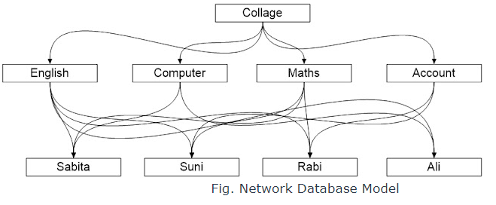

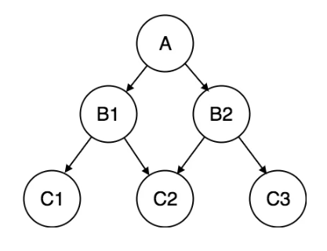

1. **Object-Oriented Database Model**

The object-oriented database model was introduced to overcome the disadvantage of other database models. This database model is a logical organization of the real-world objects (entities), constraints on them, and relations among them.

A database model that captures object-oriented concepts such as class hierarchy, inheritance, and method is an object-oriented database model. An object-oriented database model is a collection of objects whose behavior and state, and relationship are defined in accordance with an object-oriented database model. An object-oriented database management system is one that allows the definition and manipulation of an object-oriented database.

For example, the object-oriented database is shown in fig below;

## 

## Entity-relationship Model

In this database model, relationships are created by dividing object of interest into entity and its characteristics into attributes.

Different entities are related using relationships.

E-R Models are defined to represent the relationships into pictorial form to make it easier for different stakeholders to understand.

This model is good to design a database, which can then be turned into tables in relational model(explained below).

Let's take an example, If we have to design a School Database, then **Student** will be an **entity** with **attributes** name, age, address etc. As **Address** is generally complex, it can be another **entity** with **attributes** street name, pincode, city etc, and there will be a relationship between them.

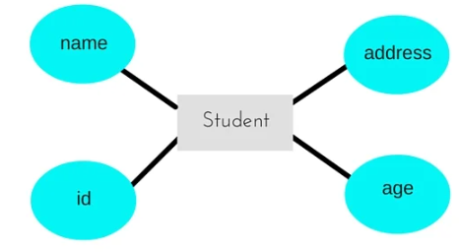

## Relational Model

In this model, data is organized in two-dimensional **tables** and the relationship is maintained by storing a common field.

This model was introduced by E.F Codd in 1970, and since then it has been the most widely used database model, infact, we can say the only database model used around the world.

The basic structure of data in the relational model is tables. All the information related to a particular type is stored in rows of that table.

Hence, tables are also known as **relations** in relational model.

